Review the scenario below. Then complete the step-by-step instructions.

L’Acier is an online cookware retailer that sells affordable, restaurant-quality kitchen equipment for home cooks. The company has many international customers, so they run paid advertising and social media campaigns 24 hours a day, seven days a week. L’Acier’s digital marketing leadership is pleased with the website traffic these campaigns are generating. However, the average number of new accounts created each week is below the expected target.

One of the company’s marketing goals for this quarter is to maximize the number of accounts created. The company is focusing heavily on growth because they’ve found that potential customers who create accounts make purchases more frequently and have a much higher lifetime value (LTV). To support this goal, your team plans to run additional ads offering a one-time discount to customers who create a new account. You’ve been asked to examine performance data for the past month to determine the best times to run these ads. The dataset includes the following metrics:

* **Users:** The number of unique individuals who visited the website
* **Sessions:** The number of sessions (site visits) per user
* **Bounce Rate:** The percentage of users who leave the site after visiting a single page
* **Pages / Session:** The average number of pages users visit per session
* **Avg. Session:** The average number of sessions per user
* **Duration:** The average length of session visits
* **Conversion Rate:** The percentage of all site visitors who create an account
* **Conversions:** The number of site visitors who create an account

You’ve already pulled the data and used sorting and filtering to answer questions, like which block of time has the highest conversion rate. Now, you’ll create three pivot tables to identify broader trends within the dataset. The pivot tables will let you examine and compare the following KPIs over the course of a typical week:

* Average number of **sessions** (site visits) at each hour of the day
* Average number of **conversions** (account creations) at each hour of the day
* Average **conversion rate** (account creation rate) at each hour of the day

Once you’ve analyzed the pivot tables, you’ll write an email to your team sharing your insights and recommending when to spend more money running the new ads and when to spend less.

**Step-By-Step Instructions**



Part 1 - Create pivot tables

**Step 1: Access the template**



To use the template for this course item, click the link below and select “Use Template.”

Link to template: [Pivot tables](https://docs.google.com/spreadsheets/d/1FiPNqgc75f2D_4exRV104K7umqnrkl0pC7W0ZNHaMNY/template/preview?resourcekey=0-KCeCbK6eMo8BFupytQU_hg#gid=1289986699)

OR

If you don’t have a Google account, you can download the template directly from the attachment below.



**Step 2: Create the first pivot table**

To create a new pivot table:

* Select any cell within the **Times and days** **dataset** in the template.
* Select *Pivot table* from the **Insert** menu.
* Select *New sheet* in the dialog box and click *Create*. This will generate a blank pivot table in a new tab (**Pivot Table 1**).
* To rename the blank pivot table, click the dropdown arrow on the **Pivot Table 1** tab and select *Rename*. Change the name to “Sessions.”

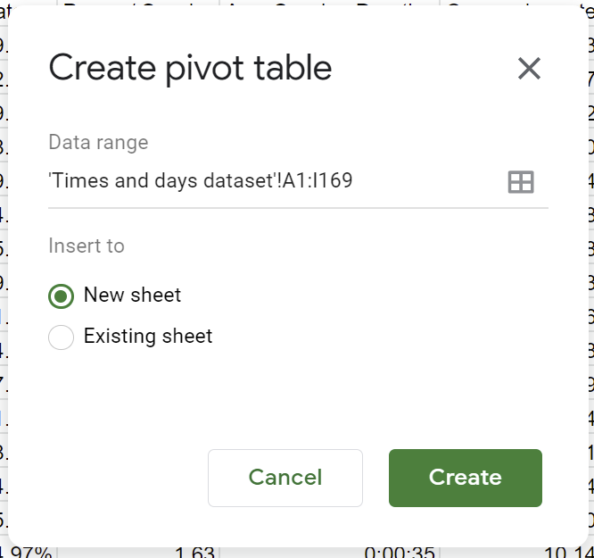

**Step 3: Add rows to the pivot table**

* In the **Pivot table editor**, select the *Add* button next to **Rows**. Then select *Hour of day* from the dropdown menu.
  + Make sure the **Order** is set to *Ascending* and that *Show totals* is checked.

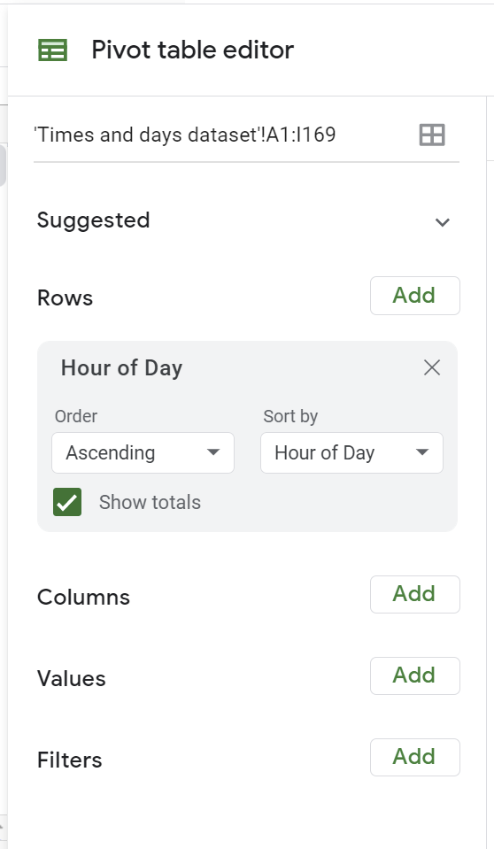

***Note:*** *If you close the* ***Pivot table editor*** *and want to open it again, select the* Edit *button on the left side of the screen.*

**Step 4: Add columns to the pivot table**

* In the **Pivot table editor**, select the *Add* button next to **Columns**.
* Select *Day of Week* from the dropdown menu.
  + Make sure the **Order** is set to *Ascending* and that *Show totals* is checked.

**Step 5: Add session values to the pivot table**

* In the **Pivot table editor**, select the *Add* button next to **Values**.
* Select *Sessions* from the dropdown menu.
  + Make sure the dropdown under **Summarize by** is set to *SUM* and the dropdown under **Show as** is set to *Default.*

**Step 6: Apply conditional formatting**

Conditional formatting, like gradient color scales, can make it easier to identify trends and themes in pivot table data. To add conditional formatting:

* Close the **Pivot table editor** if it is still open.
* Select all the cells containing data for the days of the week, omitting the cells in the **Grand total** column and row. (You will format the **Grand total** data separately.)
* Go to the **Format** menu and select *Conditional formatting*.
* Select the **Color scale** tab under **Conditional format rules**.
* The default color scale will be set to *Green to white* (making the lowest values green and the highest values white). Click the default color scale to preview different preset options in your pivot table.
* Select a color scale that distinguishes clearly between higher and lower values. Then click *Done.*
  + Recommended preset color scales include: *White to green*, *White to yellow*, and *White to red*.
* Repeat this process for the cells in the **Grand total** column and **Grand total** row, excluding the cell at the bottom-right corner of the table. You may want to select a different color scale to distinguish the totals from the rest of the table.

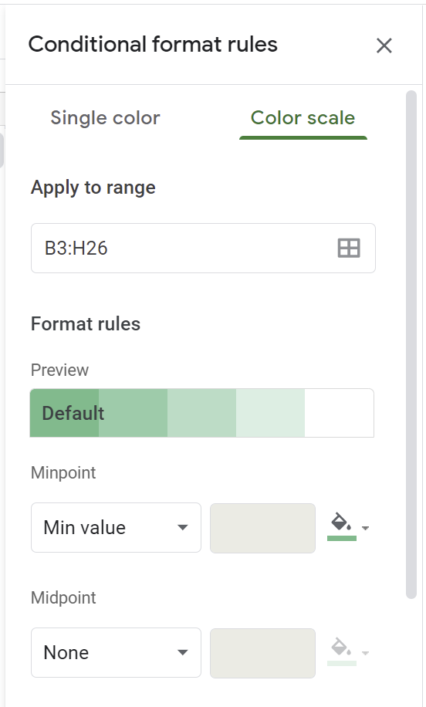

**Step 7: Create a second pivot table**

* Click the dropdown arrow on the **Sessions** pivot table tab and select *Duplicate*. This will create a copy titled **Pivot Table 1**.
* Click the dropdown arrow on the **Pivot Table 1** tab and select *Rename*. Change the name to “Conversions.” (The conditional formatting will apply to the new value.)
* Open the **Pivot table editor** in the new table by selecting *Edit*.
* Remove *Sessions* from the **Value** field and add *Conversions* in its place.

**Step 8: Create a third pivot table**

* Repeat the process described in **Step 7** to create a third pivot table in a new tab.
* Rename this table “Conversion rate” and add *Conversion rate* to the **Value** field.
* Select *AVERAGE* from the dropdown menu under **Summarize by**. (**Show as** should be set to *Default*.) This will make the **Grand Total** column and row display averages rather than sums.

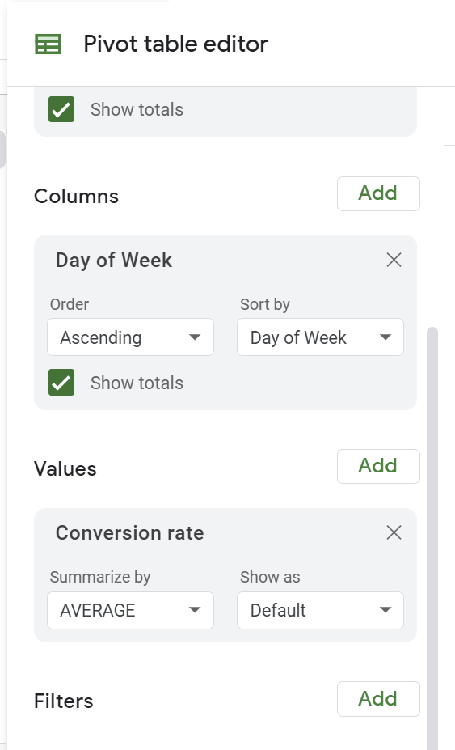

Part 2 - Analyze the data and inform your team

**Step 1: Access the template**



To use the template for this course item, click the link below and select “Use Template.”

Link to template: [Data insights email](https://docs.google.com/document/d/1wqEYk5laF-uzFe5yjNu_FQK6Qc2Q6R9dRTQZLBifDEs/template/preview?resourcekey=0-RhLuDz8ahrEjBr5NCxlrfg)

OR

If you don’t have a Google account, you can download the template directly from the attachment below.



**Step 2: Review pivot table data**

Examine the three pivot tables in your pivot tables template. Consider the following guiding questions as you review each table:

* What day of the week has the highest volume or rate in each table?
  + Which day has the lowest volume or rate?
* What times of day have the highest volume or rate in each table?
  + What times have the lowest volume or rate?
* Are there any notable trends in volume or rate (high or low) over the course of the week?

Record your insights in the **Notes** section of the **Data insights email** template. Be sure to save any notes you take, as they will be helpful in a future activity.

**Step 3: Compare pivot table data**

Compare the pivot tables to one another to identify trends and inconsistencies. In other words, you want to find out whether the volume of each metric rises and falls in a similar way across all three tables.

Consider the following guiding questions as you compare the tables:

* Are there blocks of time that have a high volume of sessions, but a low conversion rate or volume of conversions?
* Are there blocks of time that have a high conversion rate, but a low-moderate volume of conversions or sessions?

Record your insights in the **Notes** section of the **Data insights email** template. Be sure to save any notes you take, as they will be helpful in a future activity.

**Step 4: Share insights with your team**

Based on your insights, make suggestions to adjust your strategy to maximize conversions. Write them next to the lettered bullets in the **Email** section of the **Data insights email** template. Make suggestions according to the following prompts:

1. Identify 3–4 blocks of time (at least two hours in length) during the week to run additional ads.
   1. ***Hint:*** *Identify blocks that have high conversion rates and at least a moderate volume of sessions. (Note that the average conversion rate is 12.75%.)*
2. Identify 3-4 blocks of time (at least two hours in length) on weekdays when you should run fewer ads. (Try to select a number of hours that’s greater than or equal to the number of blocks you chose to run more ads.)
   1. ***Hint:*** *Identify blocks that have a relatively high volume of sessions but a low conversion rate or few conversions.*

Then, record the total number of hours when you’ve suggested running more ads, and when you’ve suggested running fewer.

**Pro Tip: Save your work**

Finally, be sure to save the work you did to complete this activity. This can help you work through your thought processes and demonstrate your experience to potential employers.

**What to Include in Your Response**



Be sure to include the following elements in your completed activity:

* Three pivot tables with the average number of sessions, conversions, and the conversion rate at each hour of the day
* Conditional formatting that distinguishes between higher and lower values
* Notes that consider the guiding questions and identify patterns in the pivot table data
* Three suggestions for how to adjust your strategy and budget to increase conversions

